**Project Design Phase-II**

**Technology Stack (Architecture & Stack)**

|  |  |
| --- | --- |
| Date | 31 January 3035 |
| Team ID | LTVIP2025TMID34195 |
| Project Name | EduTutor AI: Personalized Learning with Generative AI and LMS Integration |
| Maximum Marks | 4 Marks |

**Technical Architecture:**

The Deliverable shall include the architectural diagram as below and the information as per the table1 & table 2

**Example: Order processing during pandemics for offline mode**

**Reference:** [**https://developer.ibm.com/patterns/ai-powered-backend-system-for-order-processing-during-pandemics/**](https://developer.ibm.com/patterns/ai-powered-backend-system-for-order-processing-during-pandemics/)

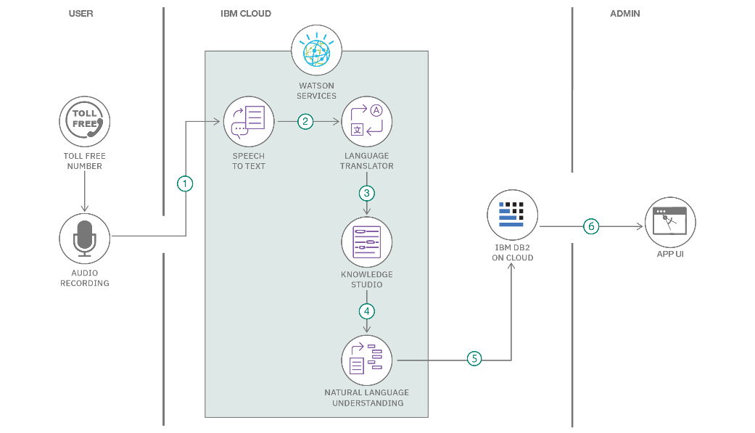

Guidelines:

Include all the processes (As an application logic / Technology Block)

Provide infrastructural demarcation (Local / Cloud)

Indicate external interfaces (third party API’s etc.)

Indicate Data Storage components / services

Indicate interface to machine learning models (if applicable)

**Table-1 : Components & Technologies:**

|  |  |  |  |
| --- | --- | --- | --- |
| **S.No** | **Component** | **Description** | **Technology** |
| 1 | User Interface | Web UI for students and educators | FastAPI Templates / HTML / CSS / JavaScript |
| 2 | Application Logic-1 | Backend routing and API handling | Python / FastAPI / Uvicorn |
| 3 | Application Logic-2 | Quiz generation and student input processing | Granite LLM via IBM Watsonx |
| 4 | Application Logic-3 | Student feedback and answer evaluation | IBM Watsonx NLP APIs |
| 5 | Database | Structured user data and session history | PostgreSQL |
| 6 | Cloud Database | Vector embeddings of quiz and student data | Pinecone Vector DB |
| 7 | File Storage | Temporary quiz storage and system logs | Local Filesystem / Cloud Storage |
| 8 | External API-1 | Sync Google Classroom data | Google Classroom API |
| 9 | External API-2 | Authentication and identity verification | Google OAuth 2.0 |
| 10 | Machine Learning Model | AI-driven quiz creation and evaluation | Watsonx + Granite Foundation Models |

**Table-2: Application Characteristics:**

| **S.No** | **Characteristics** | **Description** | **Technology** |
| --- | --- | --- | --- |
| S.No | Characteristics | Description / Technology | S.No |
| 1 | Open-Source Frameworks | FastAPI, Uvicorn, PostgreSQL, Pinecone (free tier), Jinja2 templates | 1 |
| 2 | Security Implementations | OAuth 2.0, SHA-256 encryption, role-based access control (RBAC), secure API tokens | 2 |
| 3 | Scalable Architecture | 3-tier architecture with loosely coupled microservices; containerized deployment via Docker | 3 |
| 4 | Availability | Cloud-hosted with auto-scaling and failover support; Google Cloud or Render Cloud | 4 |

**References:**

[**https://c4model.com/**](https://c4model.com/)

[**https://developer.ibm.com/patterns/online-order-processing-system-during-pandemic/**](https://developer.ibm.com/patterns/online-order-processing-system-during-pandemic/)

[**https://www.ibm.com/cloud/architecture**](https://www.ibm.com/cloud/architecture)

[**https://aws.amazon.com/architecture**](https://aws.amazon.com/architecture)

[**https://medium.com/the-internal-startup/how-to-draw-useful-technical-architecture-diagrams-2d20c9fda90d**](https://medium.com/the-internal-startup/how-to-draw-useful-technical-architecture-diagrams-2d20c9fda90d)